**Assignment 1 - Practicing Components**

Time to practice what you learned about Components. In this assignment, you're going to create, use and style your own components and see practice how you can build up your Angular app with Components.

The snapshot below explains the example app you're starting with and which tasks should be completed as part of this assignment.

Make sure to also answer why you implemented the solution you chose to use.

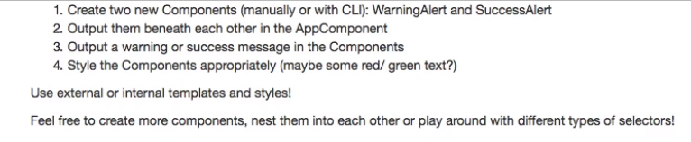

**Questions for this assignment**

**Please complete the tasks outlined in the instructions above. Why did you choose the approach you took? Which problems did you encounter?**

**Download resource files**

* basics-assignment-1-start.zip